For a diagnostic laboratory website, the goal is not just to make it visually attractive. It should do three things:
- Build trust — visitors should feel confident that the lab provides reliable testing and professional service.
- Make finding tests easy — visitors should quickly find their required test, understand the details, and know the price or how to enquire.
- Convert visitors into customers — visitors should be able to book a test, request a home sample collection, or contact the lab through WhatsApp with minimal effort.
For your client, I recommend designing the website as a modern healthcare booking and information platform, with a mobile-first layout, clear medical information, strong trust signals, and prominent booking options.

1. Recommended website structure
Here is the complete section plan I would use for a professional diagnostic laboratory website.
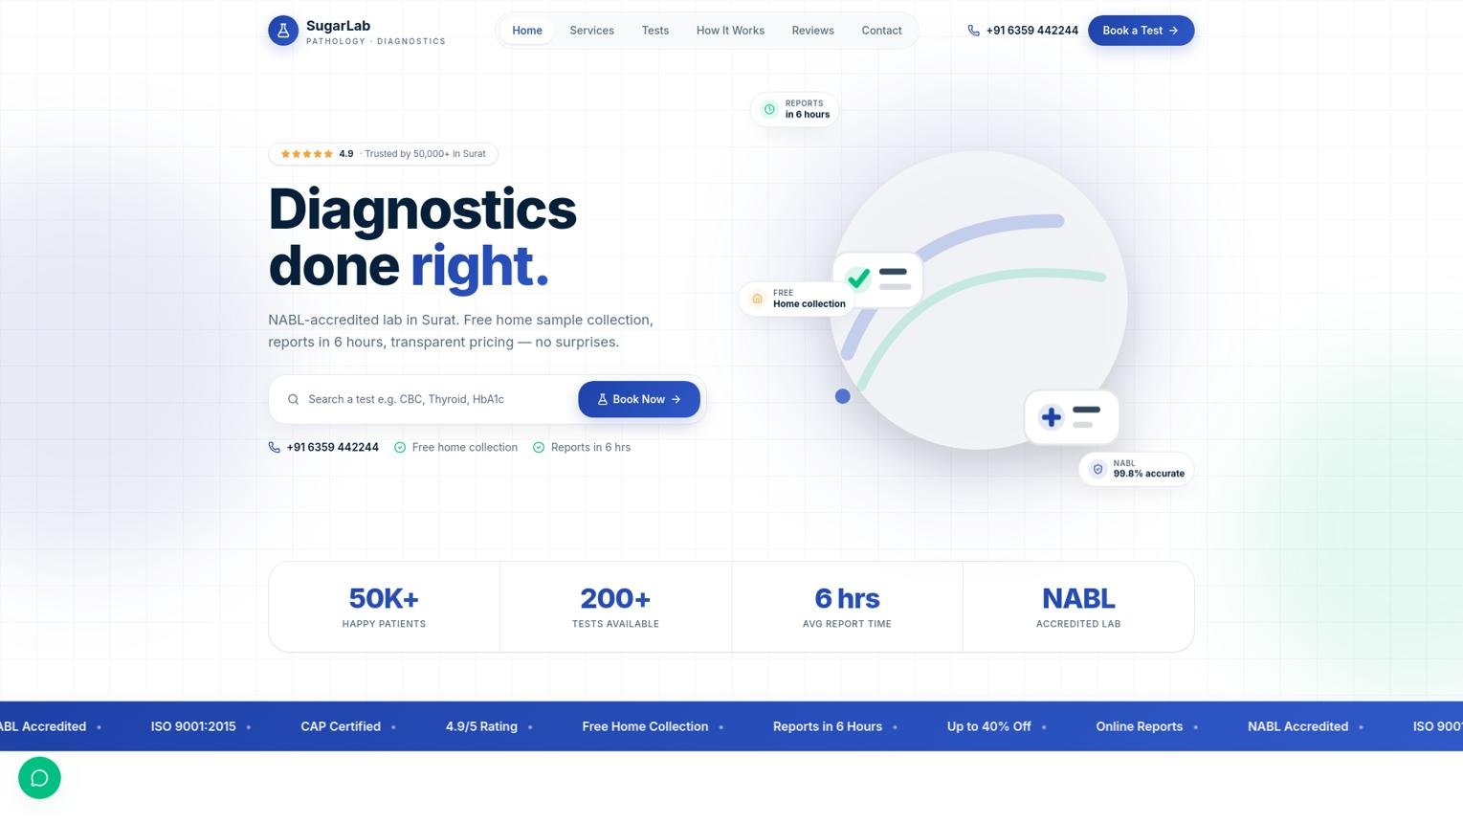

1. Hero section — First impression
Highest priority
This is the first section visitors see. It should immediately communicate what the lab offers and how to book.
Include:
- A strong headline, such as “Accurate Testing. Trusted Care.”
- A short description of the laboratory's services.
- A prominent Book a Test button.
- A Book Home Sample Collection button.
- A search bar: “Search for a test or health package.”
- A real laboratory, phlebotomist, or sample collection image.
Conversion tip: Keep the booking button visible without scrolling on mobile.
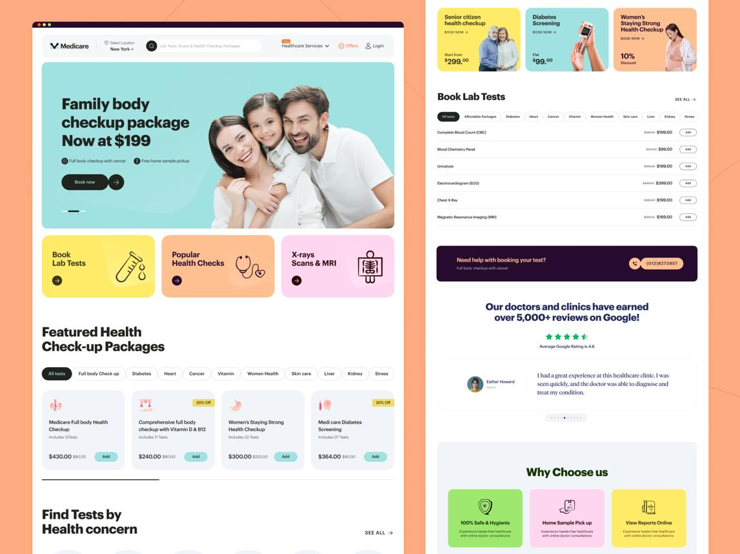

2. Search tests and health packages
Visitors often arrive looking for one specific test. Help them find it immediately.
Include:
- Search by test name.
- Search by health condition or purpose, where medically appropriate.
- Popular tests.
- Full body checkup and preventive screening packages.
- Test categories with “View all” links.
- Price, sample type, preparation requirements, and report turnaround time where verified.
Conversion tip: Add an “Add to booking” or “Book this test” action to each test card.
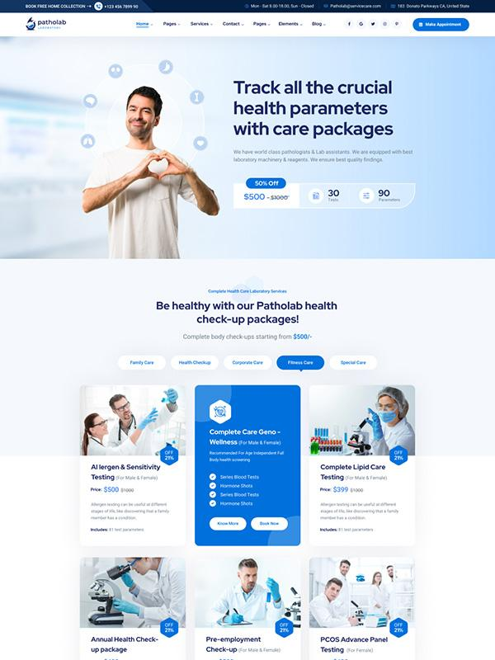

3. Popular health packages
Package cards can make it easier for customers to choose a suitable group of tests.
Include:
- Basic health checkup.
- Comprehensive health checkup.
- Diabetes screening.
- Thyroid profile.
- Women's health screening.
- Senior citizen health packages.
Each card can show the actual price, included tests, preparation instructions, and a booking button.
Conversion tip: Clearly explain what each package includes. Avoid suggesting that a package diagnoses every condition.


4. Why choose our laboratory?
Explain why customers should trust this lab rather than choosing another provider.
Include verified details such as:
- Applicable NABL accreditation or other certifications.
- Qualified laboratory professionals.
- Quality-control procedures.
- Modern testing equipment.
- Home sample collection availability.
- Convenient report access.
- Transparent pricing and customer support.
Conversion tip: Use real credentials, equipment photographs, and specific evidence instead of generic claims such as “100% accurate results.”
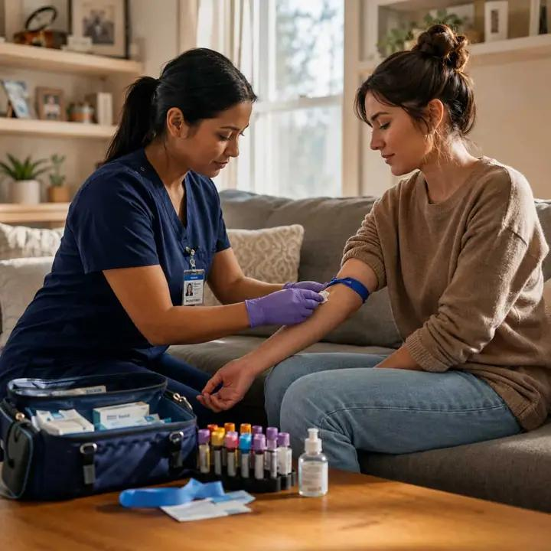

5. Home sample collection
This can be one of the strongest customer-conversion sections, particularly for families, older adults, and busy professionals.
Include:
- How home collection works.
- Areas covered.
- Available collection slots.
- Applicable collection fees.
- Preparation instructions.
- A Schedule Home Collection button.
Conversion tip: Make the process look simple: select tests, enter your location, choose a time, and confirm the booking.
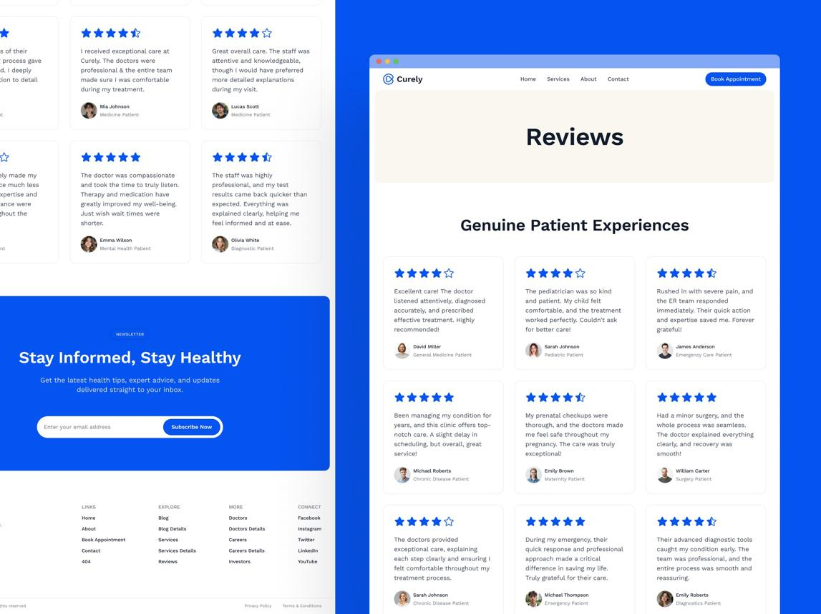

6. Customer reviews and testimonials
People want reassurance from other customers before booking a medical service.
Include:
- Genuine Google reviews, where available.
- Verified customer feedback.
- Ratings linked to their actual source.
- Comments about staff behavior, convenience, and collection experience.
Conversion tip: Use real testimonials with permission. Never create fake reviews or imply that customer satisfaction proves a medical result is accurate.
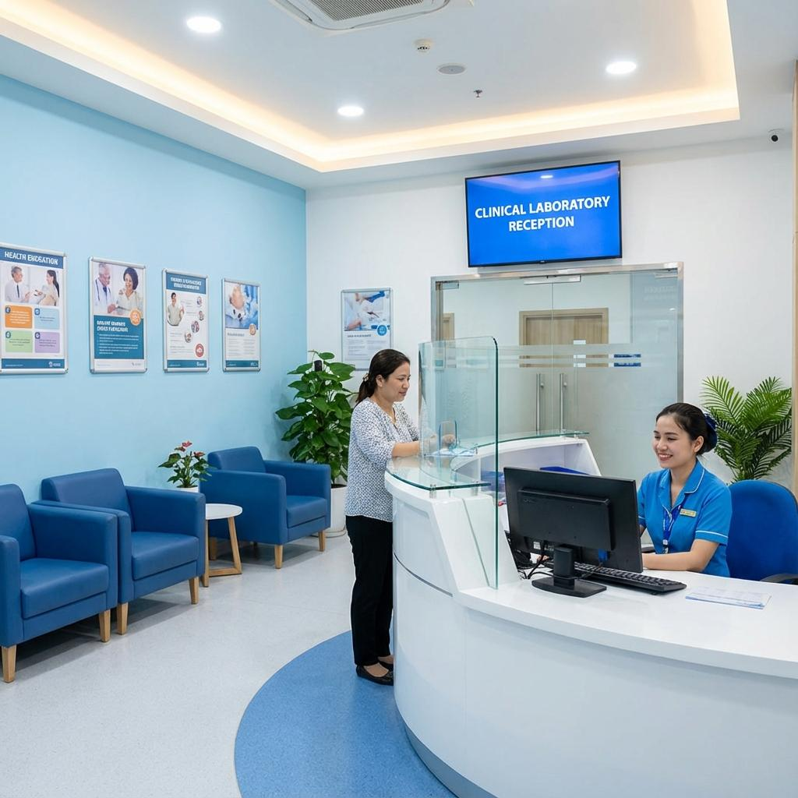

7. Find our lab and collection centres
Help visitors confirm that the laboratory is accessible and genuinely operating.
Include:
- Address and embedded map.
- Opening hours.
- Phone number and WhatsApp contact.
- Branch locations.
- Parking or accessibility information, if applicable.
- Directions button.
Conversion tip: Add a “Call now” action on mobile.


8. Online report access
Patients often return to a laboratory website to obtain their reports.
Include, if supported:
- A “Download Reports” or “View Reports” button.
- A secure patient report portal.
- Instructions for accessing reports.
- A support contact for report-related issues.
Conversion tip: Make report access easy to find in the main navigation. Do not expose reports or sensitive patient details through public links.
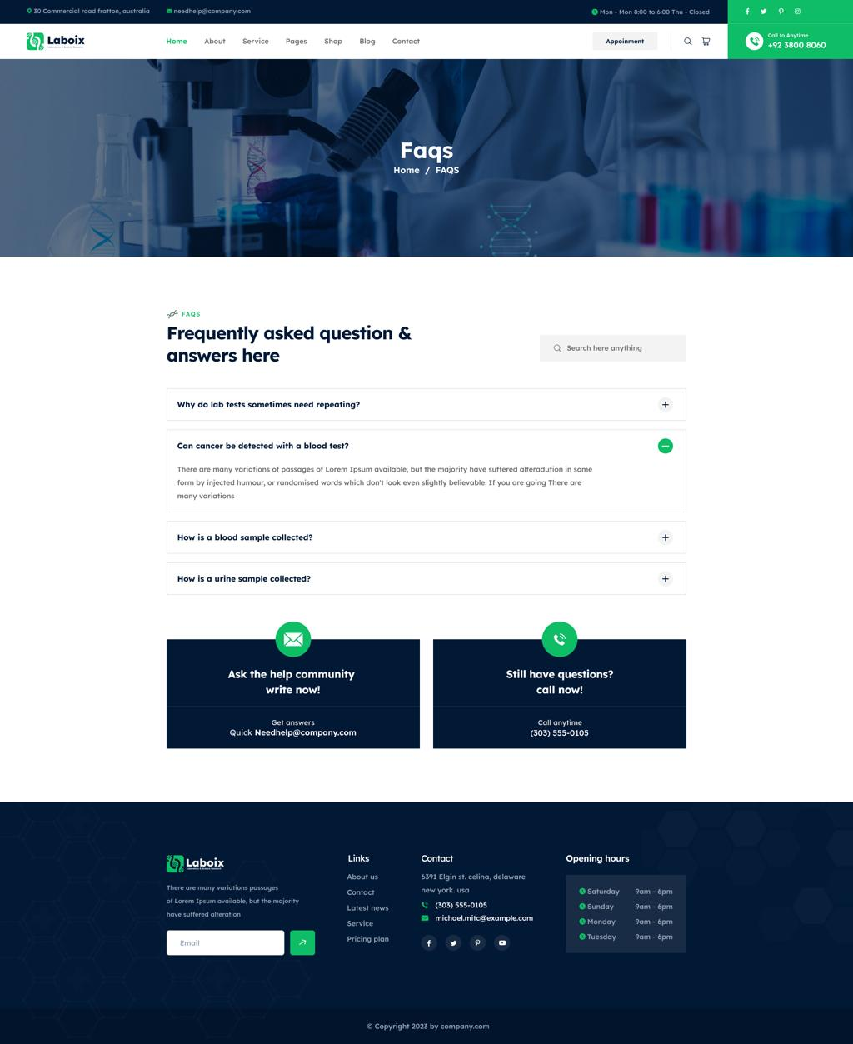

9. Frequently asked questions
Answer questions that might otherwise stop a visitor from booking.
Examples:
- Do I need to fast before my test?
- How can I book a test?
- Do you collect samples at home?
- When will my report be ready?
- How can I access my report?
- What payment methods are accepted?
- Can I reschedule a booking?
Conversion tip: Place a relevant “Book a Test” link below the answers.
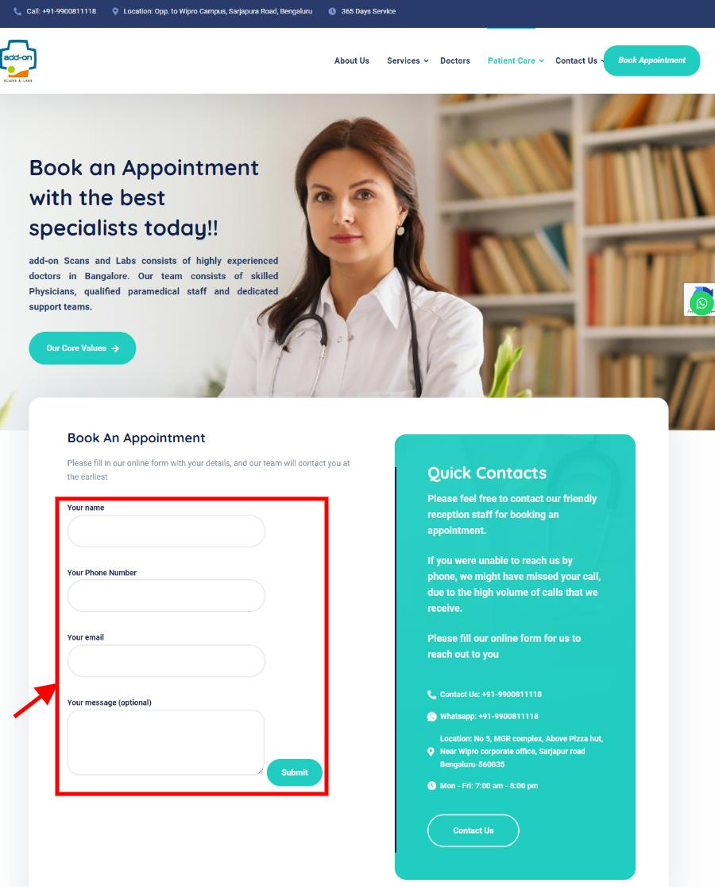

10. Final booking call to action
Give visitors who reach the bottom a clear next step.
Example headline: “Your Health Check Starts Here.”
Include:
- Book a Test.
- Schedule Home Collection.
- Call the Lab.
- Chat on WhatsApp.
Use one prominent primary action and a few supporting contact options.

2. Essential pages your website should have
Don't put every piece of information on the homepage. Build a homepage that attracts visitors and separate pages that help them make decisions.
Home
Trust, popular tests, packages, home collection and booking actions.
All Tests / Test Categories
Searchable catalogue organized by category, with individual test detail pages.
Health Packages
Compare package prices, included tests and preparation requirements.
Book a Test
Select tests, patient details, collection method and appointment slot.
Home Collection & Locations
Serviceable areas, branch details, hours and collection scheduling.
Reports
Secure access to patient reports, if the lab supports an online report system.
About Us & Contact
Laboratory background, qualifications, accreditations, address and support.

3. Test categories that make browsing easier
For a laboratory that offers many types of tests, use a visual category grid with clear icons and a search function.

Blood Tests
CBC, hemoglobin, blood sugar and other blood investigations.
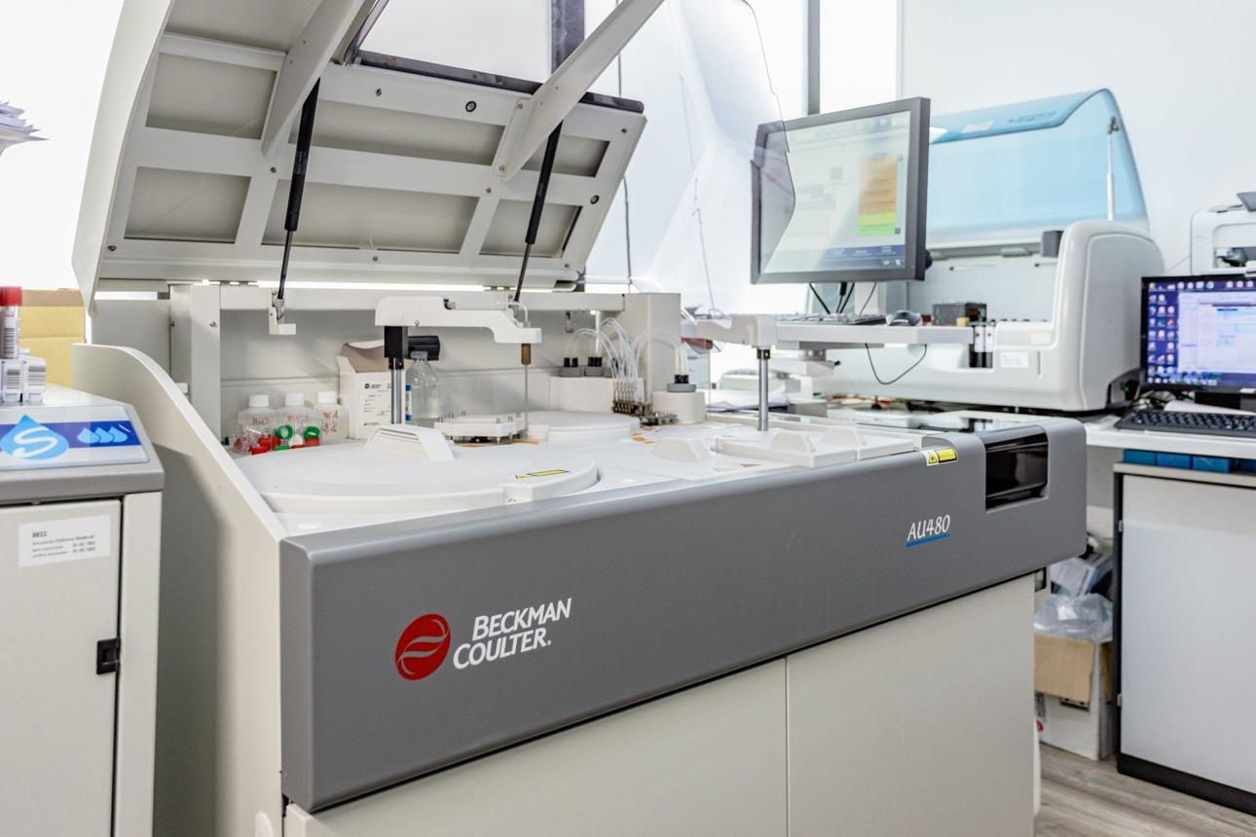
Biochemistry
Liver function, kidney function, lipid profile and related tests.
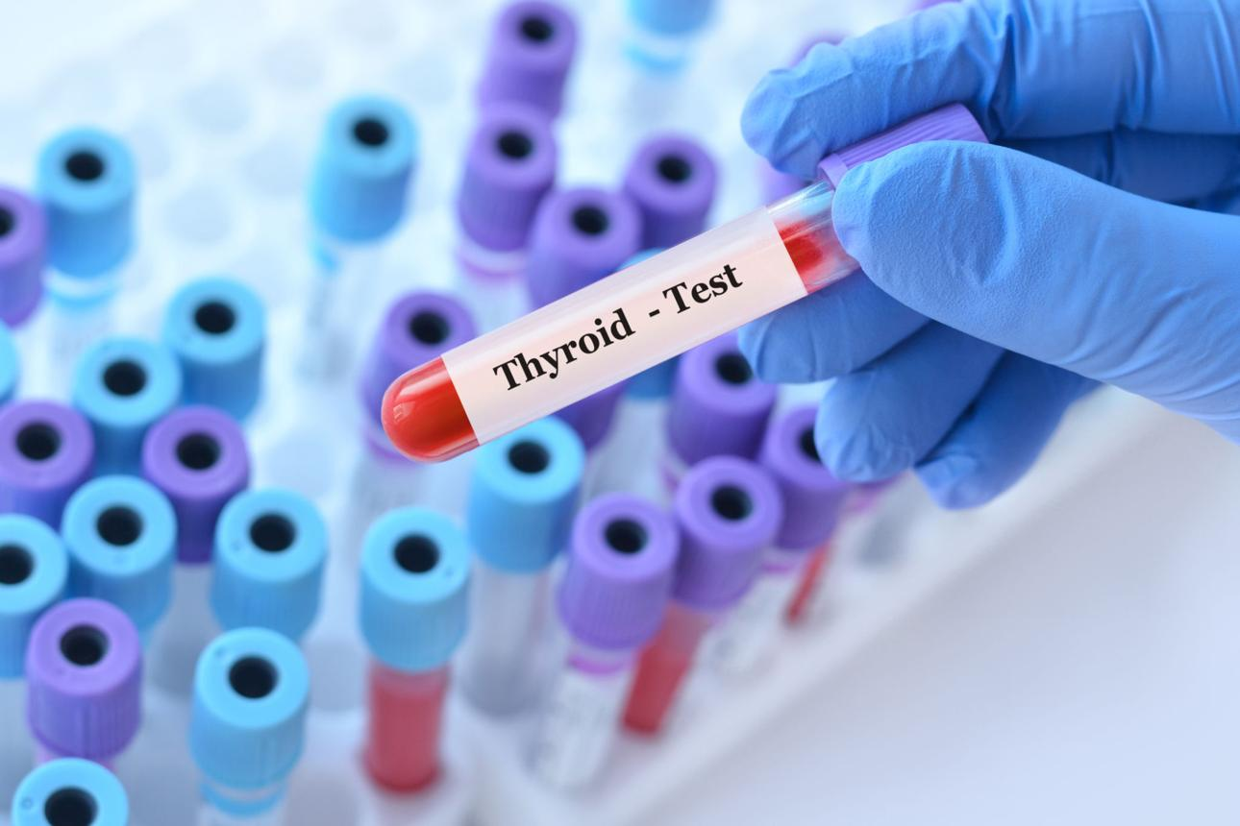
Hormones & Thyroid
Thyroid profiles and available hormone tests.
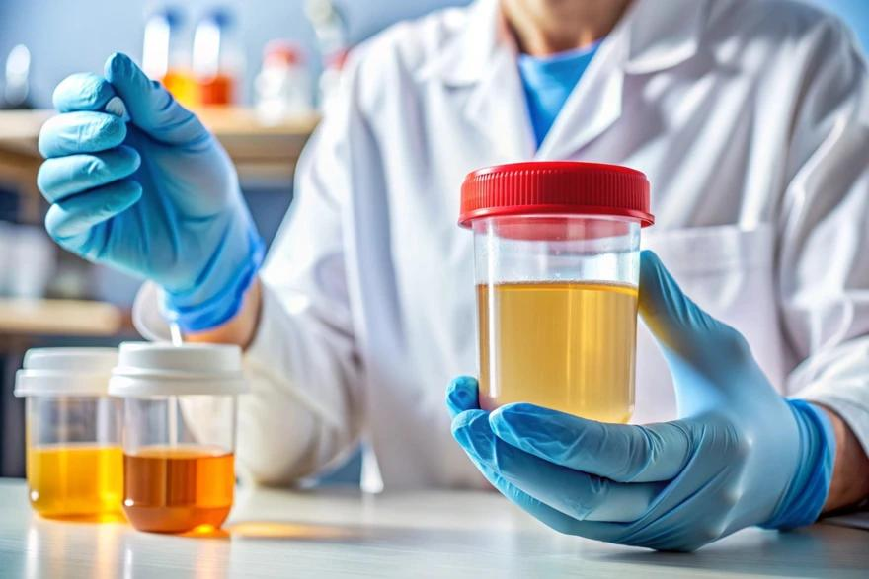
Urine & Stool Tests
Routine examination, culture and other available investigations.

Microbiology
Culture tests and other microbiological investigations offered by the lab.
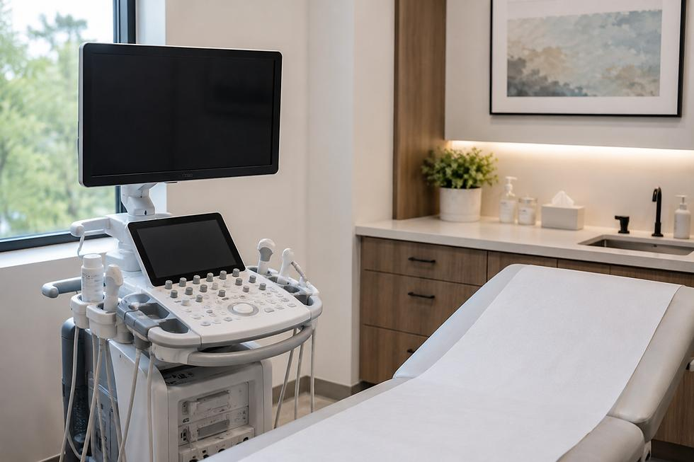
Imaging & Other Tests
Ultrasound, X-ray or other diagnostic services, if available.
These are sample categories. The final catalogue should match the client's actual test list and capabilities.

What should each individual test page contain?
For example, when a visitor selects a CBC test, show:
- Test name and short, medically reviewed description.
- Actual price and any applicable discount.
- Sample type and collection method.
- Fasting or other preparation requirements.
- Expected report turnaround time.
- Home collection availability.
- A clear Book This Test button.
- Related tests and FAQs.
This structure helps the website appear more complete and can also support search engine visibility for individual tests.

4. Conversion features that turn visitors into customers
These are the features I would prioritize if the client's objective is to generate actual bookings.
Smart test search
Let users search by test name and quickly view matching tests, prices and booking options. Include common alternative names where appropriate.
WhatsApp booking
Open a prefilled message containing the selected test or package, quantity, and booking enquiry. Avoid putting sensitive medical information in the message.
Location-based home collection
Let customers enter their PIN code to check whether home sample collection is available at their location.
Appointment scheduling
Offer available collection dates and time slots. Confirm a booking only after the system or lab has accepted it.
Transparent package offers
Show genuine package savings and the included tests. Use real prices and clearly disclose any conditions.
Persistent mobile booking bar
Keep a compact bottom bar with “Book Test” and “WhatsApp” actions while users browse. Ensure it doesn't cover page content.

5. The visual design I recommend
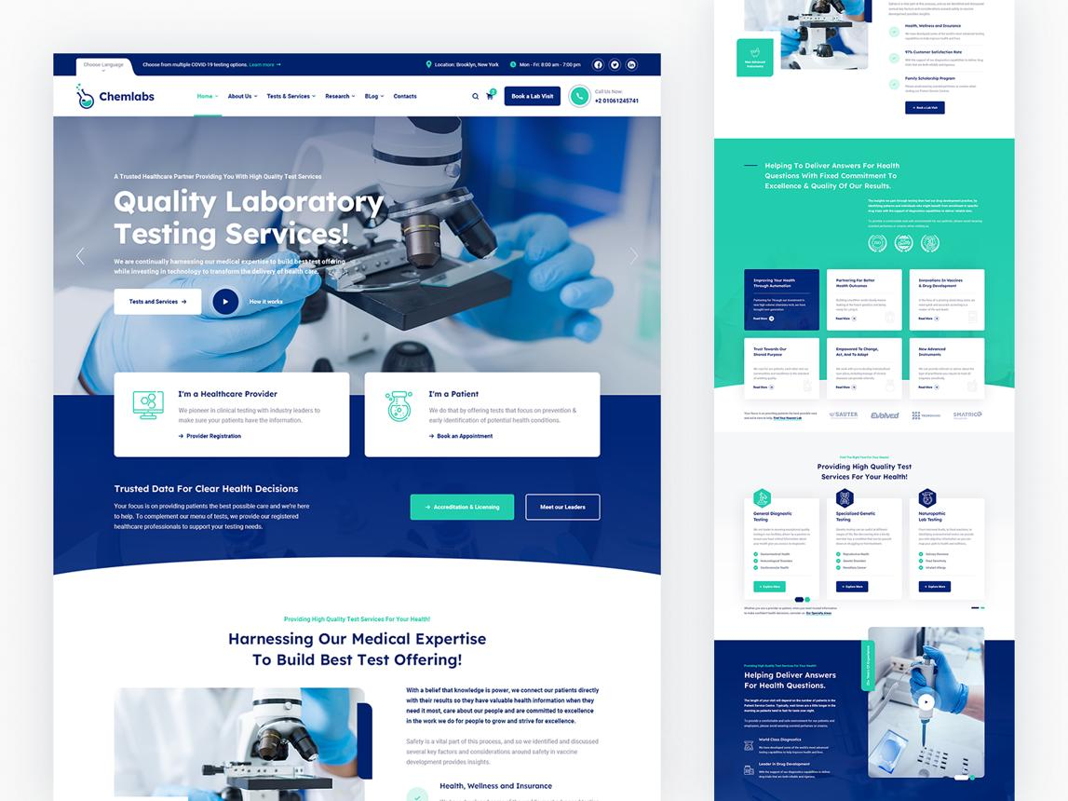
Color palette
- Deep navy or blue for confidence.
- Teal for a clean healthcare accent.
- White or very light grey for backgrounds.
- A restrained green for appropriate positive indicators.
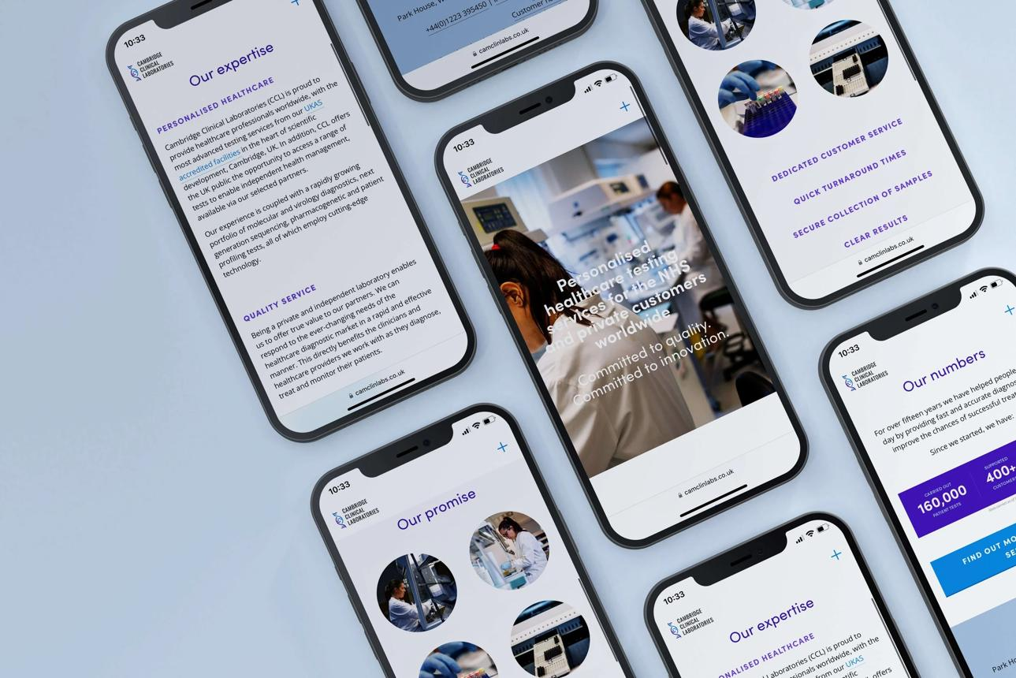
Typography and layout
- Clear, readable fonts.
- Short headings and compact descriptions.
- Consistent card spacing and rounded corners.
- Large, accessible buttons and touch targets.
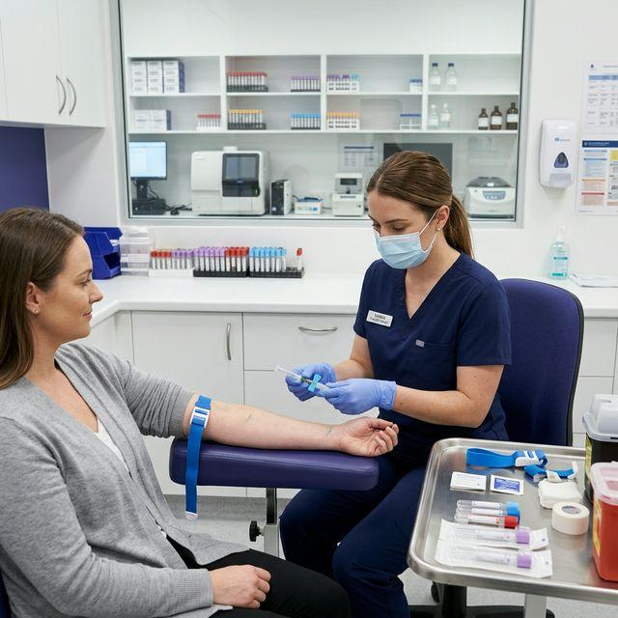
Photography
- Use real lab photographs whenever possible.
- Show qualified staff, collection procedures and facilities.
- Avoid excessive generic stock photos and exaggerated medical claims.
For mobile users, keep the header compact, make test search prominent, avoid oversized banners, and ensure the booking process requires as few steps as practical.

6. Footer and trust details
Include a complete footer with:
- Laboratory address, phone, email and working hours.
- Quick links to test categories and packages.
- Home collection and report access.
- Privacy policy and terms of service.
- Booking cancellation and refund policy, if applicable.
- Applicable accreditation details and registration information.
- Copyright and business identity.
Because this is a healthcare website, privacy is especially important. Collect only the patient information required for booking, protect any report portal with appropriate authentication, and do not expose personal medical information in URLs or public pages.

7. Recommended homepage order
This is the order I would use to move a visitor from discovering the service to booking it.
01
Header & navigation
Tests · Packages · Home Collection · Reports
02
Hero + test search
Communicate value and enable immediate action
03
Popular tests & categories
Help visitors find their required investigation
04
Health packages
Make suitable package options easy to compare
05
Why trust our lab?
Show verified credentials and quality practices
06
Home sample collection
Explain the process and invite bookings
07
Reviews & testimonials
Reinforce confidence with genuine feedback
08
Lab locations & report access
Support practical needs and returning customers
09
FAQs
Resolve remaining questions and objections
10
Final booking CTA
Convert interested visitors
11
Footer
Contact details, policies and business information

